

**Dr Kate Kenny**

Dr Kenny graduated from Dublin Dental University Hospital, Trinity College in 2006. Following completion of her Vocational Training year she spent two years working in general practice and the HSE in Dublin and a further one year in the Dublin Dental University Hospital as a Senior House Officer. In 2010 she moved to Leeds to undertake a Professional Doctorate in Paediatric Dentistry and in 2011 was appointed as a Specialist Registrar in a split post between Leeds and Hull. On completion of specialist training and her Professional Doctorate Dr Kenny was appointed as a Clinical Lecturer in The School of Dentistry, University of Leeds. She is Deputy Director of the Postgraduate Programme and is involved in both undergraduate and postgraduate teaching. In 2017 she was awarded the Royal College of Surgeons Research Fellowship to begin her PhD work to develop a minimum dataset for traumatic dental injuries. She was selected as an Engagement Excellence Fellow for the University of Leeds in 2018. Her main research interests are dental trauma, outcome set development, care pathway development and public participation and engagement in research.

**Lecture Title: Dento-Alveolar Trauma: Optimising outcomes in the short, medium and long term.**

Lecture Outline

The lecture starts with a brief refresher on the epidemiology and aetiology of dental trauma. Diagnosis of traumatic dental injuries is discussed in detail, including appropriate use of special investigations to ensure an accurate and comprehensive diagnosis for each traumatised tooth. Once an accurate diagnosis has been made, prognosis can be discussed more accurately with the child and parent. The biology of tooth healing is then described. The lecture finishes with discussion and description of best practice to ensure optimal outcomes in the short, medium and long-term, including planning for loss of failing anterior teeth.



**Dr Eva Lauridsen**

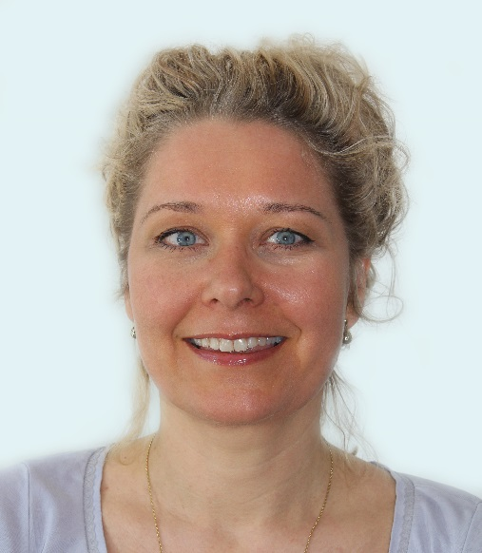

Eva Lauridsen (DDS, PhD)graduated from the School of Dentistry, University of Copenhagen in 1998. She has a background in Paediatric Dentistry and is currently employed as Head of Department at the Resource Centre for Rare Oral Diseases, Copenhagen University Hospital (Rigshospitalet). For the last ten years Eva has been part of the Dental Trauma Guide research group and she has obtained her PhD in the field of Dental Traumatology. Dr Eva Lauridsen is a fellow of the International Association of Dental Traumatology.

**Lecture Title: Traumatic dental injuries in the primary dentition**

Nearly one third of all children experience accidents causing dental trauma. The choice of treatment should be based on considerations on how to minimize stressful treatment situations to avoid initiating dental fear in a young child. Due to the close relationship between the root of the primary tooth and the developing permanent tooth germ, healing complications of the primary tooth may affect the formation of the permanent tooth. It is therefore important to evaluate the risk of complications such as pulp necrosis, infection related resorption and ankylosis in order to make the best long term treatment plan for the child. In this presentation, results from a recent study including 900 traumatized primary teeth will be presented, and treatment decisions will be discussed.



**Professor Helen Rodd**

Professor Rodd has a Chair in Paediatric Dentistry at the School of Clinical Dentistry, University of Sheffield, UK, and holds the post of Deputy Director for Teaching and Learning. Her current research interests lie principally in the field of child-centred oral health research. This has focussed on the impact of dental and facial differences on children’s psychosocial status as well as evaluating young people's experiences of various dental conditions and treatment modalities. This complements her clinical interest in developmental enamel defects. She works within a unique multidisciplinary children’s oral health research group (<https://www.sheffield.ac.uk/dentalschool/research/create>). She has played a leading role nationally within the British Society of Paediatric Dentistry, being a past president as well as Scientific Chair of the 2015 International Association of Paediatric Dentistry Congress and current member of the IAPD Congress Site Selection Committee. In her ‘other’ life she enjoys cycling around the world, having many adventures!

**Lecture 1 Title: The ‘trauma’ of trauma: psychosocial impacts of traumatic dental injuries on children and their families**

The dental literature has a strong tradition of epidemiological, clinical and laboratory research relating to traumatic dental injuries (TDIs). Psychosocial research, however, is a more recent line of enquiry, and one that is still in its infancy, particularly where children and young people are concerned. In this presentation, we will consider how TDIs may have wider impacts on children and their families. Compromised dental aesthetics and function may negatively affect a young person’s wellbeing and social interactions in a number of different ways. Indeed, the whole family may experience psychosocial impacts arising from the child’s injury. Furthermore, the need for patients to undergo,



sometimes complex and prolonged, courses of treatment may bring its own positive or negative effects. This lecture seeks to provide an overview of the recent literature to highlight the ways in which TDIs impact on children, so that clinicians may have a greater understanding of their young patients’ needs and perspectives.

**Lecture 2 Title: What do children really think? Involving children in oral health research and service evaluations**

Children have invaluable insights to give us about their dental conditions and treatment experiences, providing we find the right way of asking them! Traditional research methods have not viewed children as ‘experts’ and research has been conducted ‘on’ children, rather than ‘with’ them. This session will provide a strong rationale for why children should be included in oral health research and service evaluation. We will then describe qualitative and quantitative approaches for involving them throughout the research process, from the choice of the research question and the design of the study right through to the interpretation of the data and dissemination of the findings.